Electoral College Fast Facts
Source: US House of Representatives
Established in Article II, Section 1 of the U.S. Constitution, the Electoral College is the formal body which elects the President and Vice President of the United States. Each state has as many "electors" in the Electoral College as it has Representatives and Senators in the United States Congress, and the District of Columbia has three electors. When voters go to the polls in a Presidential election, they actually are voting for the slate of electors vowing to cast their ballots for that ticket in the Electoral College.

Electors
Most states require that all electoral votes go to the candidate who receives the plurality in that state. After state election officials certify the popular vote of each state, the winning slate of electors meet in the state capital and cast two ballots—one for Vice President and one for President. Electors cannot vote for a Presidential and Vice Presidential candidate who both hail from an elector’s home state.
- Maine and Nebraska employ a “district system” in which two at-large electors vote for the state’s popular plurality and one elector votes for each congressional district’s popular plurality. In the November 2, 2004, election, Colorado voters rejected a “proportional system” in which electors would vote proportionally based on the state’s popular vote.
The District of Columbia and 26 states “bind” their electors to vote for their promised candidate, via a number of methods including oaths and fines. In the modern era, very rarely have electors voted for someone other than for whom they pledged. Though still rare, electors more commonly changed their vote in the 19th century—particularly on the vote for Vice President. Such “faithless electors” have never decided a Presidency.
- There has been one faithless elector in each of the following elections: 1948, 1956, 1960, 1968, 1972, 1976, and 1988. A blank ballot was cast in 2000. In 2016, seven electors broke with their state on the presidential ballot and six did so on the vice presidential ballot.

Procedure
Since the mid-20th century, on January 6 at 1:00 pm before a Joint Session of Congress, the Vice President opens the votes from each state in alphabetical order. He passes the votes to four tellers—two from the House and two from the Senate—who announce the results. House tellers include one Representative from each party and are appointed by the Speaker. At the end of the count, the Vice President then declares the name of the next President.
- The date of the count was changed in 1957, 1985, 1989, 1997, 2009, and 2013.
- Sitting Vice Presidents John C. Breckinridge (1861), Richard Nixon (1961), Hubert Humphrey (1969), and Al Gore (2001) all announced that they had lost their own bid for the Presidency.

Objections
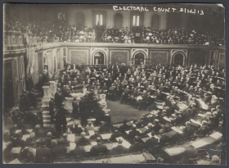
Collection of the U.S. House of Representatives
The House and Senate met in a Joint Session on February 12, 1913, to count Electoral College votes for the 1912 presidential election.
Since 1887, 3 U.S.C. 15 sets the method for objections to electoral votes. During the Joint Session, Members of Congress may object to individual electoral votes or to state returns as a whole. An objection must be declared in writing and signed by at least one Representative and one Senator. In the case of an objection, the Joint Session recesses and each chamber considers the objection separately in a session which cannot last more than two hours with each Member speaking for no more than five minutes. After each house votes on whether or not to accept the objection, the Joint Session reconvenes and both chambers disclose their decisions. If they agree to the objection, the votes in question are not counted. If either chamber does not agree with the objection, the votes are counted.
- Objections to the Electoral College votes were recorded in 1969 and 2005. In both cases, the House and Senate rejected the objections and the votes in question were counted.

Amending the Process
Originally, the Electoral College provided the Constitutional Convention with a compromise between the popular election of the President and congressional selection.
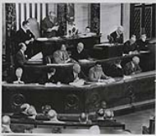
Collection of the U.S. House of Representatives
The 1953 electoral vote count declared Dwight D. Eisenhower the winner.
- The 12th Amendment—ratified in 1804—changed the original process, allowing for separate ballots for determining the President and Vice President. See Electoral College and Indecisive Elections for more information.
- The District of Columbia has had three electors since the 23rd Amendment was ratified in 1961.
There have been other attempts to change the system, particularly after cases in which a candidate wins the popular vote, but loses in the Electoral College.
- Five times a candidate has won the popular vote and lost the election. Andrew Jackson in 1824 (to John Quincy Adams); Samuel Tilden in 1876 (to Rutherford B. Hayes); Grover Cleveland in 1888 (to Benjamin Harrison); Al Gore in 2000 (to George W. Bush); Hillary Clinton in 2016 (to Donald J. Trump).
The closest Congress has come to amending the Electoral College since 1804 was during the 91st Congress (1969–1971). H.J. Res. 681 proposed the direct election of a President and Vice President, requiring a run off when no candidate received more than 40 percent of the vote. The resolution passed the House in 1969, but failed to pass the Senate.

Contingent Elections
In the case of an Electoral College deadlock or if no candidate receives the majority of votes, a “contingent election” is held. The election of the President goes to the House of Representatives. Each state delegation casts one vote for one of the top three contenders to determine a winner.
- Only two Presidential elections (1800 and 1824) have been decided in the House.
- Though not officially a contingent election, in 1876, South Carolina, Florida, and Louisiana submitted certificates of elections for both candidates. A bipartisan commission of Representatives, Senators, and Supreme Court Justices, reviewed the ballots and awarded all three state’s electoral votes to Rutherford B. Hayes of Ohio, who won the presidency by a single electoral vote.

In defense of the electoral college

It's a stabilizing force for our democracy, even if you didn't like the results of last week's election.
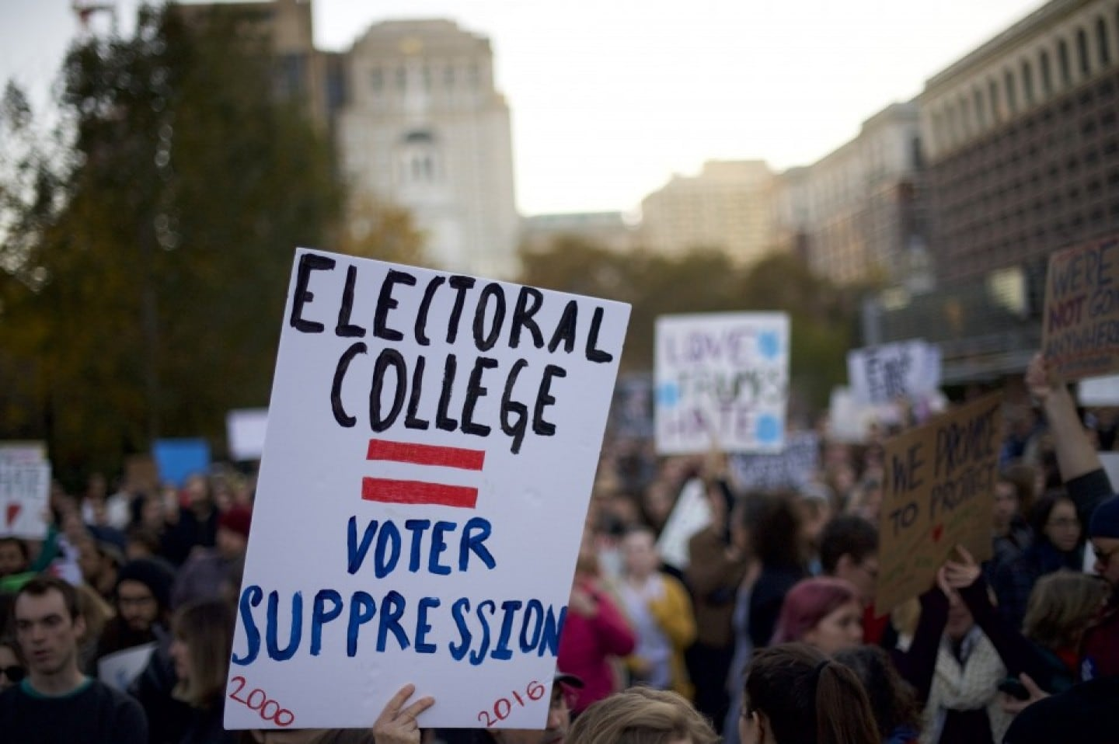Protesters demonstrate against President-elect Donald Trump outside Independence Hall in Philadelphia on Nov. 13. (Mark Makela/Getty Images)
By Allen Guelzo and James Hulme
Washington Post, November 15, 2016 at 8:57 a.m. EST
There is hardly anything in the Constitution harder to explain, or easier to misunderstand, than the electoral college. And when a presidential election hands the palm to a candidate who comes in second in the popular vote but first in the electoral college tally, something deep in our democratic viscera balks and asks why the electoral college shouldn’t be dumped as a useless relic of 18th century white, gentry privilege.

Actually, there have been only five occasions when a closely divided popular vote and the electoral vote have failed to point in the same direction. No matter. After last week’s results, we’re hearing a litany of complaints: the electoral college is undemocratic, the electoral college is unnecessary, the electoral college was invented to protect slavery — and the demand to push it down the memory hole.

All of which is strange because the electoral college is at the core of our system of federalism. The Founders who sat in the 1787 Constitutional Convention lavished an extraordinary amount of argument on the electoral college, and it was by no means one-sided. The great Pennsylvania jurist James Wilson believed that “if we are to establish a national Government,” the president should be chosen by a direct, national vote of the people. But wise old Roger Sherman of Connecticut replied that the president ought to be elected by Congress, since he feared that direct election of presidents by the people would lead to the creation of a monarchy. “An independence of the Executive [from] the supreme Legislature, was in his opinion the very essence of tyranny if there was any such thing.” Sherman was not trying to undermine the popular will, but to keep it from being distorted by a president who mistook popular election as a mandate for dictatorship.

Quarrels like this flared all through the convention, until, at almost the last minute, James Madison “took out a Pen and Paper, and sketched out a mode of Electing the President” by a “college” of “Electors … chosen by those of the people in each State, who shall have the Qualifications requisite.”

The Founders also designed the operation of the electoral college with unusual care. The portion of Article 2, Section 1, describing the electoral college is longer and descends to more detail than any other single issue the Constitution addresses. More than the federal judiciary — more than the war powers — more than taxation and representation. It prescribes in precise detail how “Each State shall appoint … a Number of Electors, equal to the whole Number of Senators and Representatives to which the State may be entitled in the Congress”; how these electors “shall vote by Ballot” for a president and vice president; how they “shall sign and certify, and transmit sealed to the Seat of the Government of the United States, directed to the President of the Senate” the results of their balloting; how a tie vote must be resolved; what schedule the balloting should follow; and on and on.
Above all, the electoral college had nothing to do with slavery. Some historians have branded the electoral college this way because each state’s electoral votes are based on that “whole Number of Senators and Representatives” from each State, and in 1787 the number of those representatives was calculated on the basis of the infamous 3/5ths clause. But the electoral college merely reflected the numbers, not any bias about slavery (and in any case, the 3/5ths clause was not quite as proslavery a compromise as it seems, since Southern slaveholders wanted their slaves counted as 5/5ths for determining representation in Congress, and had to settle for a whittled-down fraction). As much as the abolitionists before the Civil War liked to talk about the “proslavery Constitution,” this was more of a rhetorical posture than a serious historical argument. And the simple fact remains, from the record of the Constitutional Convention’s proceedings (James Madison’s famous Notes), that the discussions of the electoral college and the method of electing a president never occur in the context of any of the convention’s two climactic debates over slavery.

If anything, it was the electoral college that made it possible to end slavery, since Abraham Lincoln earned only 39 percent of the popular vote in the election of 1860, but won a crushing victory in the electoral college. This, in large measure, was why Southern slaveholders stampeded to secession in 1860-61. They could do the numbers as well as anyone, and realized that the electoral college would only produce more anti-slavery Northern presidents.

Yet, even on those terms, it is hard for Americans to escape the uncomfortable sense that, by inserting an extra layer of “electors” between the people and the president, the electoral college is something less than democratic. But even if we are a democratic nation, that is not all we are. The Constitution also makes us a federal union, and the electoral college is pre-eminently both the symbol and a practical implementation of that federalism.

The states of the union existed before the Constitution, and in a practical sense, existed long before the revolution. Nothing guaranteed that, in 1776, the states would all act together, and nothing that guaranteed that after the Revolution they might not go their separate and quarrelsome ways, much like the German states of the 18th century or the South American republics in the 19th century. The genius of the Constitutional Convention was its ability to entice the American states into a “more perfect union.” But it was still a union of states, and we probably wouldn’t have had a constitution or a country at all unless the route we took was federalism.

The electoral college was an integral part of that federal plan. It made a place for the states as well as the people in electing the president by giving them a say at different points in a federal process and preventing big-city populations from dominating the election of a president.

Abolishing the electoral college now might satisfy an irritated yearning for direct democracy, but it would also mean dismantling federalism. After that, there would be no sense in having a Senate (which, after all, represents the interests of the states), and further along, no sense even in having states, except as administrative departments of the central government. Those who wish to abolish the electoral college ought to go the distance, and do away with the entire federal system and perhaps even retire the Constitution, since the federalism it was designed to embody would have disappeared.

None of that, ironically, is liable to produce a more democratic election system. There are plenty of democracies, like Great Britain, where no one ever votes directly for a head of the government. But more important, the electoral college actually keeps presidential elections from going undemocratically awry because it makes unlikely the possibility that third-party candidates will garner enough votes to make it onto the electoral scoreboard.

Without the electoral college, there would be no effective brake on the number of “viable” presidential candidates. Abolish it, and it would not be difficult to imagine a scenario where, in a field of a dozen micro-candidates, the “winner” only needs 10 percent of the vote, and represents less than 5 percent of the electorate. And presidents elected with smaller and smaller pluralities will only aggravate the sense that an elected president is governing without a real electoral mandate.

The electoral college has been a major, even if poorly comprehended, mechanism for stability in a democracy, something which democracies are sometimes too flighty to appreciate. It may appear inefficient. But the Founders were not interested in efficiency; they were interested in securing “the blessings of liberty.” The electoral college is, in the end, not a bad device for securing that.

Reform the Electoral College
Aug. 27, 2019 at 2:38 pm Updated Aug. 27, 2019 at 3:26 pm
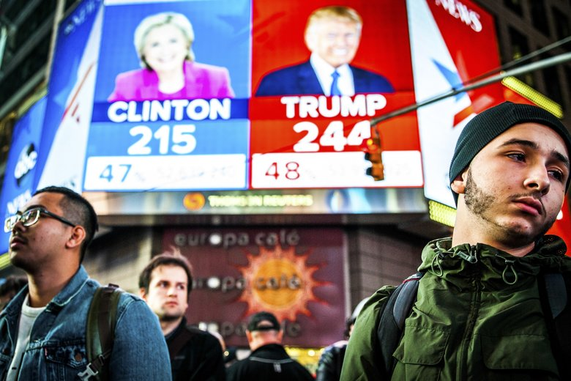Election results in Times Square in New York City Nov. 9, 2016, showed the race to the 270 electoral votes needed to win between Hillary... (George Etheredge / The New York Times) More
By The Seattle Times editorial board
The controversial way America elects presidents is barreling toward a crisis point. A federal court ruling has spotlighted the confounding nature of the system, which twice in the last five elections put presidents into office against the wishes of the majority of American voters.
Under the Constitution, the voters who select a president every four years are, in fact, picking a party-chosen slate of electors pledged to that candidate. The presidential candidate who wins a state’s popular vote gets all its electors — except in Nebraska and Maine, which split the electors by Congressional districts. These electors formally select the president after Election Day passes. This mechanism solved two problems of 1789’s America that no longer plague the nation.
Mass, instant communication — of news, commentary and campaign rhetoric — means voters have no need to designate others to make informed choices, which was the argument Alexander Hamilton made in support of the Electoral College. The system also induced southern slave states to join the union by giving them power at a time when the more populous north would have dominated a national popular election.
Today, the Electoral College turns every presidential election into a contest for the same handful of closely divided battleground states. Voters in Florida, Ohio, Pennsylvania and the upper Midwest hold the power and get candidates’ focus. Deviating from this priority list, as Hillary Clinton did in 2016, means courting electoral doom.
A decade ago, Washington joined states working to modernize the system with the National Popular Vote Interstate Compact. It takes effect only if enough states join to control the 270 Electoral College votes required to elect a president. Each state’s Electoral College votes would then be awarded to the winner of the national popular vote. But only 15 states and the District of Columbia have joined the agreement, giving it just 73% of the electors needed.
While legislatures in other states debate signing on, an alarming confluence of events has thrown Washington law into conflict with a federal court ruling. In the 2016 election, a handful of electors schemed to game the College to block Donald Trump from office. They traded votes to push the selection for president into the then-Republican controlled House of Representatives. It failed, but repercussions are playing out anyway.
Washington fines its “faithless electors” and under a new state law, will cancel and replace their votes, joining nine states that already had such laws on the books. But the 10th U.S. Circuit Court of Appeals this month found removing an elector’s vote illegal, reading the Constitution to say Electoral College voters can vote as they please. If the ruling withstands U.S. Supreme Court review, states would lose the Electoral College’s accountability mechanism and all electors would have carte blanche to ignore the people’s will.
From time to time, members of Congress attempt to abolish the Electoral College, but few get far. (Hillary Clinton promised to join this fight when she joined the U.S. Senate after the disputed 2000 presidential election, but never filed legislation.) Congress should step up to modernize the system. A place to start is to build on the Electoral College, which is enshrined in the Constitution and would be difficult to toss entirely. Instead, it should reflect the national popular vote.
Until then, Washington must champion the National Popular Vote Interstate Compact to other states so every vote in America can count the same. Washington has several nationally influential leaders in government; Gov. Jay Inslee has chaired the Democratic Governors Association, and Secretary of State Kim Wyman has chaired the Republican Secretaries of State Committee. Both should urge their peers to fight for the popular vote compact

